WEB CONTENT

About ReSoK

The Respiratory Society of Kenya (ReSoK) formerly Kenya Association for the Prevention of

Tuberculosis and Lung disease (KAPTLD) is a professional organization with a membership

constituted of health professionals and service providers with an interest in respiratory medicines mainly chest medicine specialists.

The organization is registered in Kenya as a Society by the Registrar of Societies. Leadership is provided by an elected board of management comprising mainly chest specialists and with

representation from other cadres of the healthcare profession i.e., Clinical Officers, Nurses ,and Pharmacists. A secretariat led by a Chief Executive Officer who also acts as the Technical Advisor and supported by a Programs manger and an Administration &amp; Finance Manager is responsible for the day-to-day operations.

ReSoK has been working in the area of lung health for many years with its core activities focusing on respiratory disease care and control i.e.:

Advocacy to improve the profile of Tuberculosis (TB) and lung health among policy makers, health planners and funders of healthcare programs;

Training of different cadres of healthcare professionals on TB and other lung diseases of public health importance; technical support to the National TB control program, health care providers, and smaller community-based groups in the development and implementation of TB and other lung disease care programs and in partnership with teaching and research institutions implementation of a research in TB and other lung diseases.

The society has identified Tuberculosis, Asthma, Chronic Pulmonary Disease (COPD), Tobacco cessation, non-tuberculous acute respiratory infections in both children and adults, Air pollution and Occupational Lung diseases as its key areas of work.

Our Vision:

To be the leading reference organization providing world class lung health solutions in Kenya and beyond.

Our Mission:

To promote and improve lung health in Kenya and beyond through partnership, advocacy, research and innovation, education, training, and technical support.

Our Core values:

The values that underlie our work and engagements are Integrity, Teamwork, Empowerment, Diligence and Excellence

Board Members (Picture then name)


Pro. Jumaa Bwika- Honourable Chair


Mrs. Claire Njoki Kamu- Honourable V. Chairperson

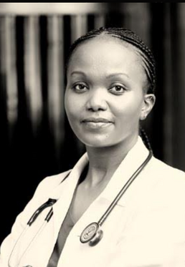
Dr. Jacqueline Wanjiku Kagima- Honourable Secretary

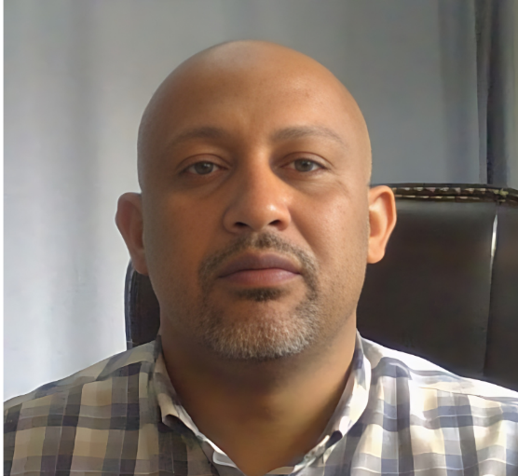
Dr. Salim Masoud- Honourable Treasurer

Dr. Newton Ang'wa- Honourable Assistant Secretary

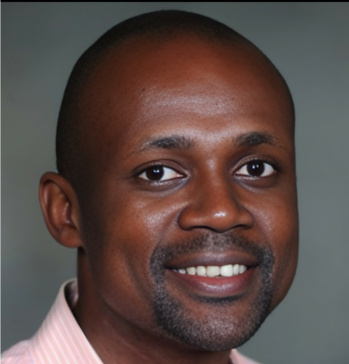
Dr. Andrew Owuor- Honourable Member

Dr.Diana Marangu- Honourable Member

Mr. Timothy Kamau Kibe- Honourable Member

Dr. Boru Okotu-Member

OUR TEAM

Professor Jeremiah Chakaya(CEO/Technical Director)

Professor Jeremiah Chakaya is a founding member of the Respiratory Society of Kenya (ReSoK) and serves as a member in the executive committee of the Pan African Thoracic Society. In April 2020 he took up a position as Professor for Global Respiratory Health at the Liverpool School of Tropical Medicine. He continues to serve as a technical expert for the Kenyan National TB Programme. At the international level, Prof. Chakaya has held several positions including, Vice Chair of the Stop TB Partnership Coordinating Board, Chair of the Strategic and Technical Advisory Group for TB (STAG-TB ) of the World Health Organization (WHO), Chair of the Global Fund’s Technical Review Panel (TRP) and President of the International Union Against Tuberculosis and Lung Disease ( the Union). He has an honorary teaching position at the school of medicine, Kenyatta University, Nairobi, Kenya.
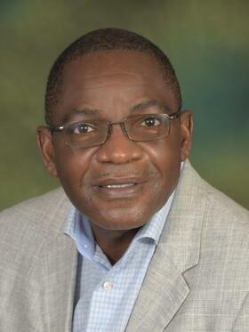

Mr Chrispine Okoth(Finance & Admin Manager)
Chrispine Okoth has been the Finance & Administration Manager at the Respiratory Society of Kenya (ReSoK) since 2009, bringing over ten years of financial management experience in the service and manufacturing sectors. His experience includes financial planning, directing, project management and execution, budgetary control, and grants management. In addition to his financial management duties, Chrispine is responsible for administrative tasks, including human resources management.
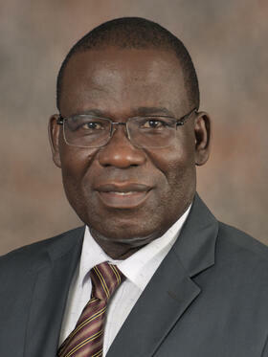

Dr Jacqueline Wanjiku Kagima (Director Training & Research)

As the Director of Training & Research at ReSoK, Kenya, Dr. Jacqueline Wanjiku Kagima aims to support the planning process for research uptake, including the development of tools for monitoring and evaluating research uptake activities. She ensures that research findings are translated into national and international policy and practice. Additionally, she oversees training programs to enhance the skills and knowledge of stakeholders. She believes that teamwork, collaboration, and partnerships are key to achieving these goals

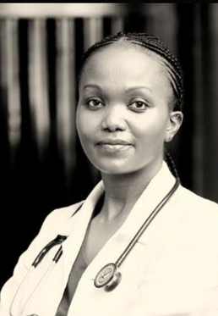

Ms Rhoda Pola(Research Coordinator - Light Consortium)

Rhoda, a research coordinator and field epidemiologist with the LIGHT Consortium since January 2024, is based in ReSoK, Kenya. She focuses on high TB prevalence among young people using a gender lens. With 12 years in the TB field, Rhoda has extensive experience, including 5 years with Kenya's National TB Programme and 7 years as a coordinator for Malaria, TB, and Leprosy in Kwale. Her Master's thesis examined TB treatment non-adherence in school children. Rhoda's passion for research and improving community health drives her work.


CONFERENCES
1. PATS & ReSoK 2023 CONGRES:
Full Name; The 3rd Biennial Pan African Thoracic Society & 7th KLHC 2023 Conference
Start end date; 7th – 10th June 2023
Venue; Sarova White Sands Convention Center, Mombasa, Kenya
Description; The 3rd Biennial Pan African Thoracic Society Conference was held in collaboration with the Respiratory Society of Kenya from 7th – 10th June 2023 in Mombasa, Kenya. The conference was a great success with over 100 delegates from different parts of Africa and beyond.
The theme of the conference was “The African Environment and Lung Health” which aimed to explore the relationship between the African environment's effect of physical elements such as air pollution and climate change, and also social factors like poverty, overcrowding, and displacement on lung health in the African context.

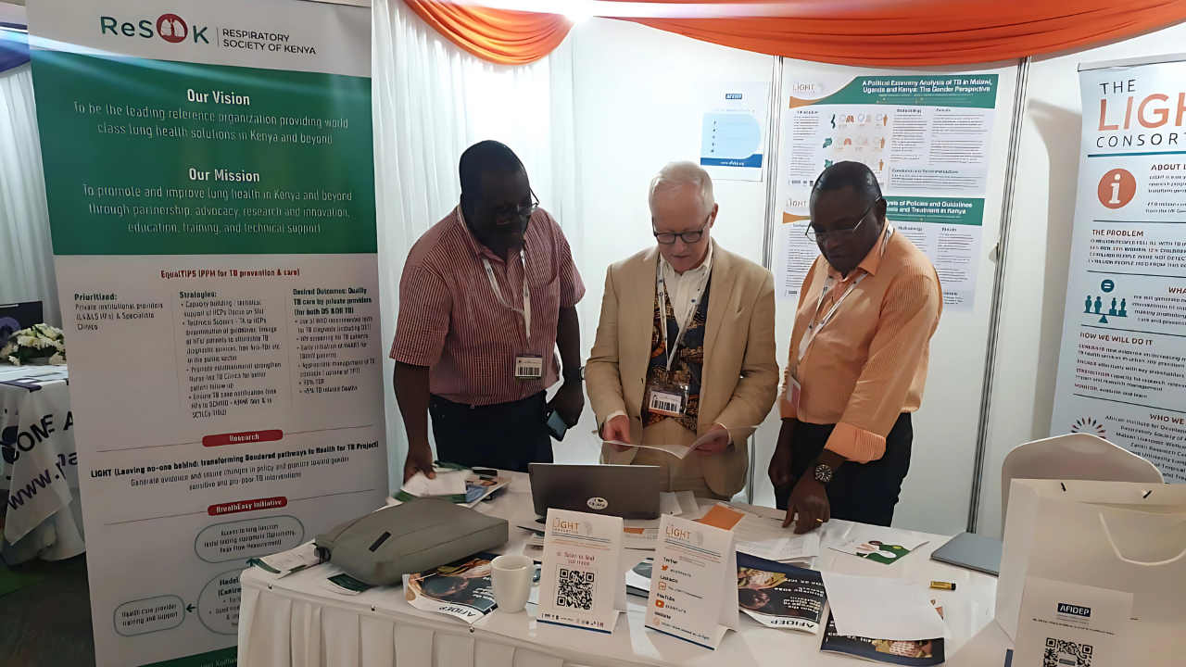
ReSoK,AFIDEP & Light resource centers booth.

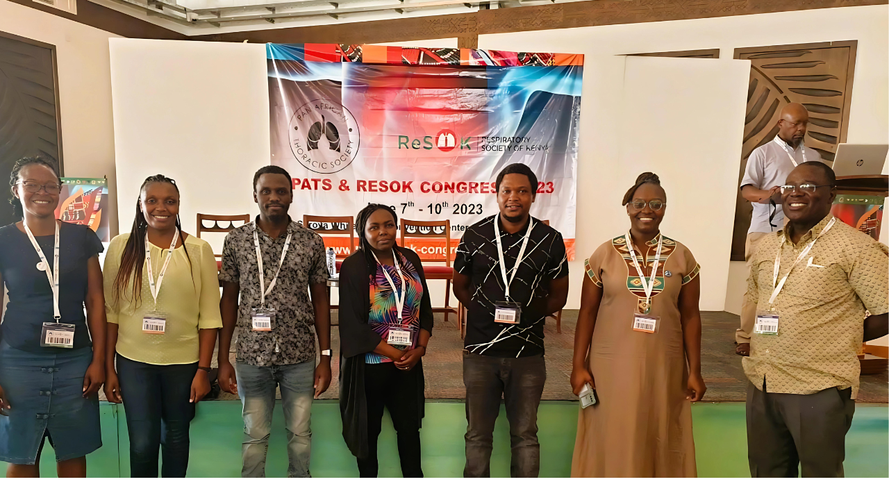
ReSoK staff participating in the conference

2. 6th KILHC 2022

Full Name; 6th Kenya Lung Health Conference
Start end date; 23rd - 25th June 2022.
Venue; Pride Inn Hotel, Shanzu Mombasa.
Description;
The 6th Kenya Lung Health Conference offers a platform to disseminate and discuss pertinent information on Lung health. The conference theme, ‘Healthy Lungs for a Better Future’ explores the need to create better solutions in global health factoring latest science and research.
Access photos here:

WORKSHOPS AND TRAININGS

2nd Pleural & advanced bronchoscopy workshop 2024.
Description;

Start end date;

Photos;
https://photos.app.goo.gl/GreMZpAuLYuPDkc37 -Skills Session.
https://photos.app.goo.gl/4ApddwKM5A6H8K1fA - Webinar.

Start end date;

Photos;

Asthma Day Celebration 2024
Description;

Start end date;

Photos;
https://photos.app.goo.gl/MPgUXnNMafDhGXELA - Day Star university-Citizens’ Monday Report.
Monday Report | How to use an inhaler: Asthma Awareness
Monday Report | Kenya joins the world in marking Asthma Day ( Part 1)
Monday Report | Kenya joins the world in marking Asthma Day ( Part 2)

1st Bronchoscopy workshop 2023
Description;

Start end date;

1 Spirometry workshop
Description;

Start end date;
Photos;
https://photos.app.goo.gl/8w2XpjUzHroSdeYr7

2 Spirometry workshop
Description;

Start end date;
Photos;
https://photos.app.goo.gl/2mdCMovNbstmgSm86

PROJECTS

ReSoK PPM
Description;

ReSoK Light

Description;

ReSoK GF Kiambu
Description;

Photos;

ReSoK PTLD

Post TB Lung Disease (PTLD) is currently being implemented within Nairobi County in 14 high burden facilities. The key Initiatives are:-
To expand the effort to provide appropriate care to people with post TB
lung disease and other forms of post TB disability by implementing a set of
interventions
To build the capacity of health care workers in managing PTLD
To fight stigmatisation of persons with PTLD through support
To address the social economic impact suffered by the PTLD patients by
rehabilitating them to their economic potential.
To mainstream ideal models at the community (guidelines, SOPs, relevant
equipment, and essential medicines) to manage PTLD at all levels
To advocate for resources for continued research and management of PTLD
Establish routine recording and reporting systems for post TB lung diseases and
other chronic lung diseases

Photos;

RESOK ASTHMA
-LUNG CANCER
-CMEs
-Alborada Grant
-Lu
Research
-PCD

PARTNERS

